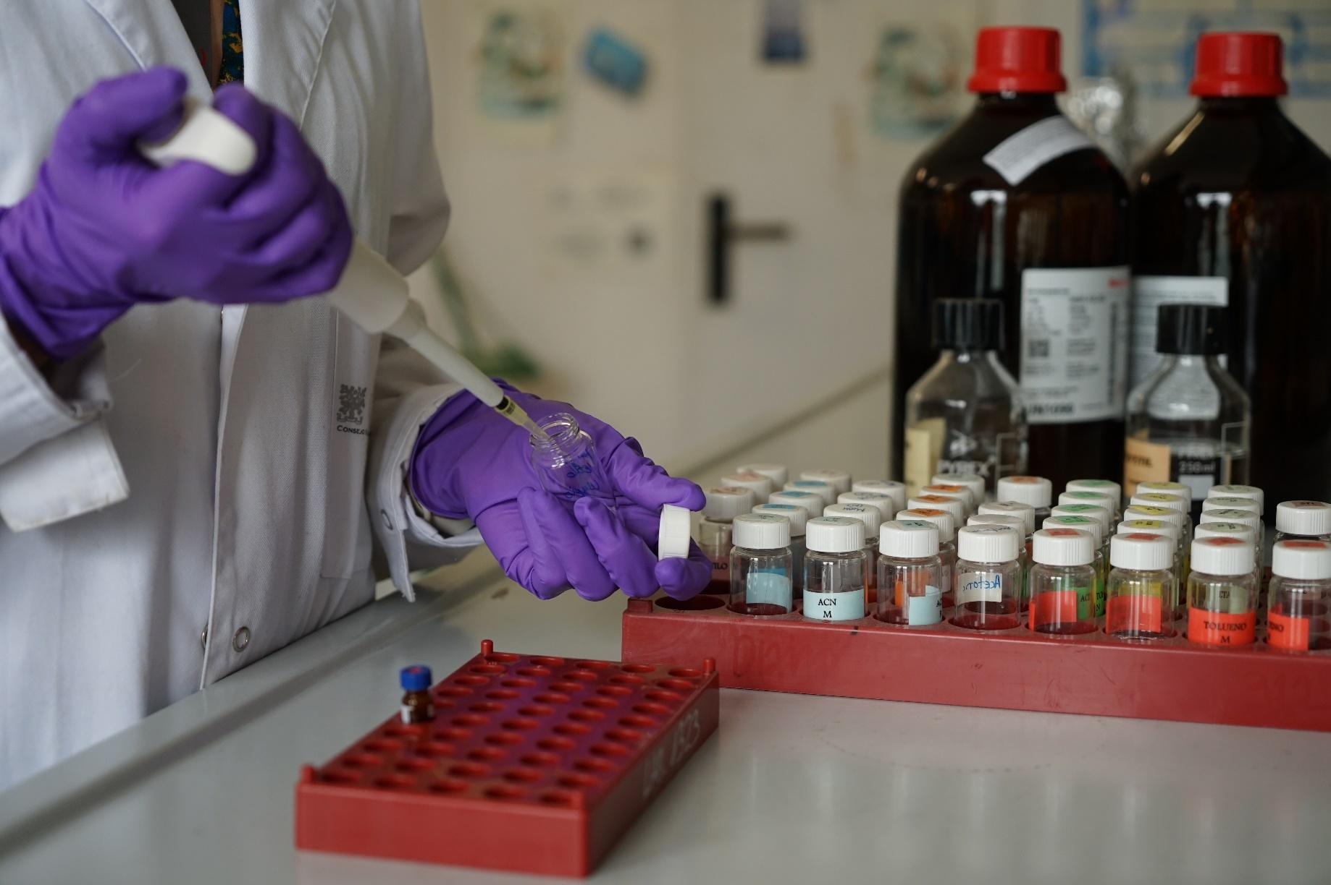

**PhD Position in Analytical Chemistry & Marine Science**

**Characterization of dissolved organic carbon by high resolution mass spectrometry and the linkage to marine microbiomes**

**The role**

The dissolved organic carbon (DOC) plays a prominent role in carbon cycling on a global scale. The DOC pool is modulated by marine microorganisms, which are the main engines driving the main global biogeochemical cycles. The linkage between DOC and microorganisms is important because it has direct implications on Earth climate and ocean health. However, advances in our understanding on DOC composition and how DOC diversity links to marine microbiomes has been hampered by limited analytical techniques. Nowadays, massive data from DOC and the microbiomes can be retrieved applying high-throughput approaches. This PhD will focus on applying meta-omics approaches to profile DOC and disentangle the linkage between chemical and taxonomical diversities in the upper ocean. The main tasks conducted during the PhD include:

* Development and application of HRMS-based non-target strategies to describe and identify organic chemicals within DOC pool
* Evaluation of the potential link between the presence of the identified chemicals with specific marine taxa

**What do we look for?**

* **Qualifications and professional experience**

**The candidate** must hold a Master’s degree from or equivalent to a Master degree awarded in the European Higher Education Area. **Master’s degree must be in Analytical Chemistry, Marine Science, Environmental Sciences, Environmental Chemistry, Bioinformatics, or similar**. Other degrees may be seen favourable if justified by motivation of the student.

* **Competences**

**We are looking for** a highly motivated person with interests in analytical chemistry to integrate environmental chemistry and oceanography. The project is cross disciplinary and would benefit from a creative and open mind team.

**The successful candidate is expected** to hold an MSc degree, has experience in analysis of organic chemicals using mass spectrometry, data analyses and/or modelling, demonstrated skills in scientific communication (including paper writing), and a willingness to learn and expand skills. Other desired skills include computer programming (e.g. R and/or Python) and experience with machine learning or large datasets.

Fluency in English is required.

**Working conditions**

* **Contract duration**: **3 years**
* Competitive salary that will commensurate with qualifications and experience
* Target start date: between November / December 2021 (it can be flexible)

**The group**

The PhD will be co-advised by 2 PI from 2 different research groups. Dr. Pablo Gago Ferrero, from Human Exposure to Organic Chemicals group, uses the last advances in analytical chemistry to obtain a more comprehensive understanding of the universe of chemicals that accumulate (or pseudo-accumulate) in humans and their link with the environment. Dr Maria Vila Costa, from Global Change and Genomic Biogeochemistry research group, focuses her research on the interaction between microorgansims and dissolved organic carbon (DOC), both biogenic (BDOC) and particularly anthropogenic (ADOC), in the environment, mainly in seawater, by means of high-throughput genomic technologies.

**The institute**

The **Institute of Environmental Assessment and Water Research (IDAEA)** is an environmental science institute devoted to the study of the human footprint on the biosphere. Much of the research work at this institute is centred on two of the great environmental challenges of our time: cleanliness and availability of water and quality of air.

Founded in 2008 as a member of the **Spanish National Research Council (CSIC)**, the Institute brings together a wide range of expertise in environmental science. It is organized under two Departments (Environmental Chemistry and Geosciences), established with a strong record of publication in top scientific journals, leading international projects, membership on international committees, and adopting a high-profile contribution to the identification and remediation of environmental problems. IDÆA has demonstrated strengths in the analysis of organic pollutants and their impact on ecosystems, the study and management of water resources, the development of multivariate resolution algorithms in chemometrics, and in the study of inhalable particulate matter and toxic gases. IDÆA has been recently awarded with the distinctive **Centre of Excellence “Severo Ochoa”** (2020-2023), distinction that indicates the high-quality scientific leadership and global impact of the work developed at the centre. We offer a diverse and inclusive environment where no discrimination against disability, gender, nationality, religion or sexual orientation will occur during the selection process.

**How to apply?**

Please submit your application as soon as possible to pablo.gago@idaea.csic.es Please include a **letter of motivation** explaining why you think you fit this position well, a **CV** with publications (if applicable), and the names and contact information of **two referees**.

For further information, please contact Dr. Pablo Gago Ferrero ([**pablo.gago.ferrero@gmail.com**](mailto:pablo.gago.ferrero@gmail.com) and Dr Maria Vila Costa ([**maria.vila@idaea.csic.es**](mailto:maria.vila@idaea.csic.es))

**Deadline: 15 December 2021** (we encourage candidates to send their application as soon as possible)