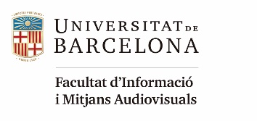

Call for participation
EUROPEAN SUMMER SCHOOL ON INFORMATION SCIENCE 2024
Villach, Austria, 26-30 August 2024

About

The European Summer School on Information Science (ESSIS 2024) is an intensive one week teaching event for BA students who want to enrol in a MA program related to information science. The lectures for core areas in IS will enable students to close their knowledge gaps and to prepare better for MA programs. One week of ESSIS could bring you 2 ECTS.

Program
The courses of ESSIS will cover the five following areas:
- Advances in Information Science
- Research Methodology in Information Science
- Principles of Information Organization and Retrieval
- Information Needs and User Studies
- Digital Content Creation and Management
In the mornings, there will be interactive lectures and group discussions. In the afternoons, students will have workshop and work on group assignments. In addition, a social program will allow you to experience Villach and its surroundings.

Organization
ESSIS 2024 is organized by School of Management at Carinthia University of Applied Sciences, Faculty of Humanities and Social Sciences University of Osijek, University of Hildesheim, and University of Barcelona. ESSIS 2024 is held with partial support by the Erasmus+ programme DECRIS - Digital Education for Crisis Situations: Times when there is no alternative (2020-1-HR01-KA226-HE-094685).

IMPORTANT DEADLINES
The application for participation is possible until March 31, 2024.
An application should include a short letter of motivation, a current CV as well your current transcript of records. Only complete applications will be considered. Please submit your application by e-mail to s.dreisiebner@fh-kaernten.at.
Notification of acceptance: 15th April 2024

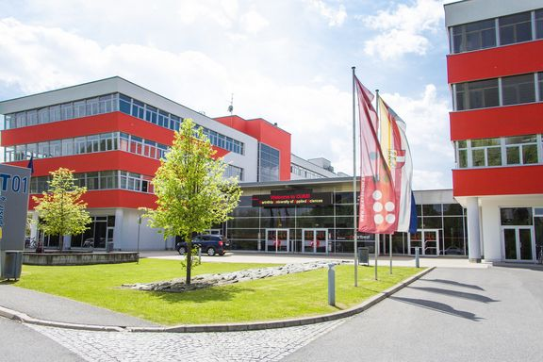
Venue
The summer school will take place on Villach Campus of Carinthia University of Applied Sciences. The Carinthia University of Applied Sciences is a dynamic and dialogue-oriented university of applied sciences with regional roots and international orientation. Founded in 1995, it has its main study and research areas in health and social affairs, technology and economics.
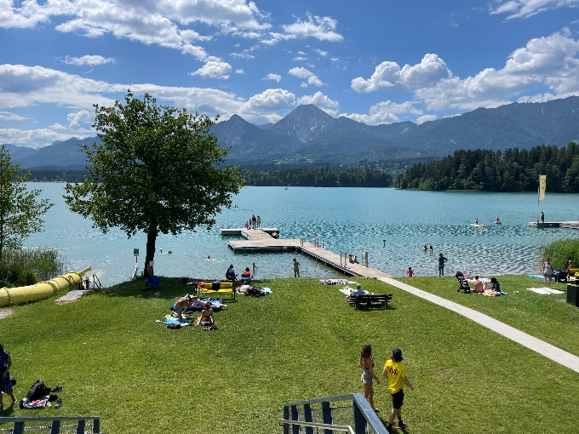
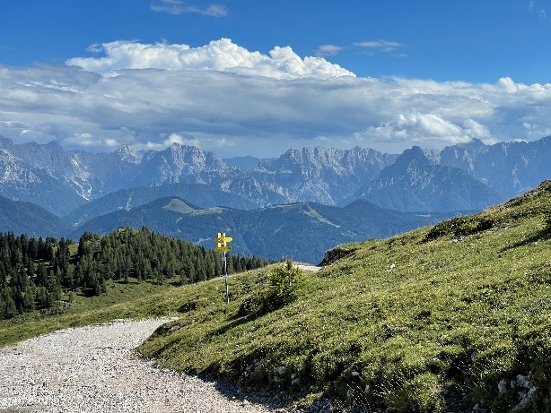
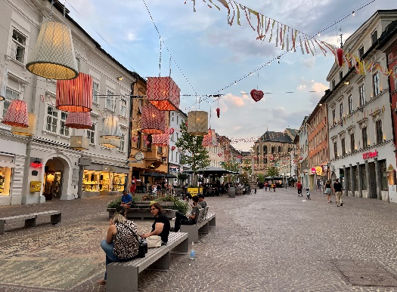
Villach (Slovene: Beljak; Italian: Villaco) is a charming city located in Southern Austria, surrounded by sparkling lakes and beautiful Alpine Mountain ranges. The picturesque architecture of the city invites you to stroll and discover. Especially on warm summer evenings, Villach unfolds a special atmosphere. Villach is a perfect destination for those who love outdoor activities connected with nature in both summer and winter. Villach is surrounded by several lakes, such as the Faaker See with its turquoise water and Ossiacher See, the largest of the nine swimming lakes in the region. From the shore of Ossiacher See, the Kanzelbahn cable car leads up to Gerlitzen, the family recreational mountain. The city also borders Dobratsch Nature Park, which is accessible through the Villach Alpine Road. The city is only a short drive from the borders of both Slovenia and Italy. Nature, sport, culture and leisure, as well as the proximity to the neighbouring countries Italy and Slovenia, draw holiday guests to the region throughout the year. You can find more interesting and useful information about Villach at: https://www.visitvillach.at/en/

Costs
The fee for participation is 220 €. This fee will include breakfast, lunch, coffee breaks, social activities, a welcome and goodbye dinner as well as a certificate of participation. In addition, you will have to cover the costs for accommodation and travel individually.

Accommodation
Students will be offered accommodation (single rooms in shared apartments) within the STUWO student dorm. The dorm is conveniently located nearby campus. The city centre, as well as two bathing lakes (Silbersee and Magdalensee) are in walking distance. The costs for accommodation will be 190 € (+ 9 € for optional package of bed linens and towels).
In case of high registration numbers, students might be also offered additional accommodation offers for a higher price.

Student Grants
Several student grants are available for students from partner institutions who want to attend ESSIS 2024. Most grant recipients are nominated by the partner universities. Selected students will receive the costs for participation fee and accommodation in Villach (5-6 nights) plus travel support.
You might also seek additional local sources for financial support. For example, there might be financial support available by the international office of your university, federal or local student support agencies or your local students union.

How to reach Villach
Villach is an important traffic junction for southern Austria and the whole Alpe-Adria region. It is easily accessible by train or car. By plane, Villach can be reached through various airports in the wider region, e.g. Klagenfurt Airport or Aeropuerto di Venezia. More information: https://connect.visitvillach.at/en/arriving-by-airplane.html

Invitation to institutions – Sponsorship
Employers, professional organizations, information agencies, publishers, and service providers are invited to consider participation at ESSIS 2024 by offering a demonstration, workshop or exhibit about their products and services, or by presenting a paper or poster about their activities and services, as related to the summer school themes.

Contact:
Programme Committee Chair
Dr. Stefan Dreisiebner
s.dreisiebner@fh-kaernten.at

