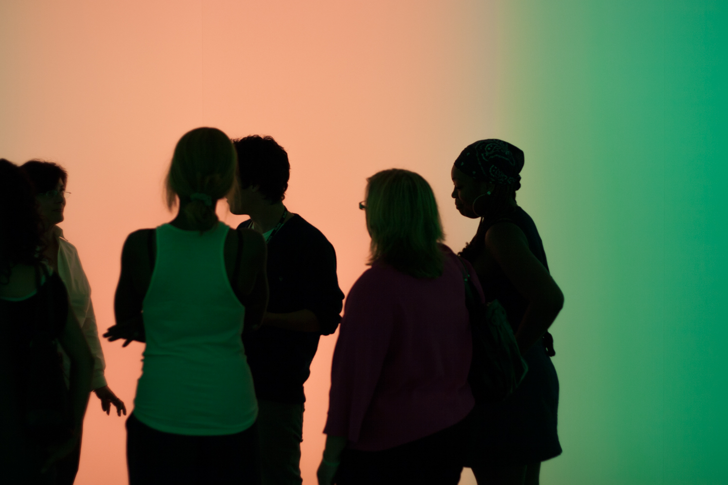

Barcelona – Berlin Summer School 2017  
Diversity in the Cultures of Physics

**Information for applicants and application form**

**Summer School Dates:** **July 17 – August 11, 2017**

Barcelona: July 17 – July 29, 2017

Berlin: July 30 – August 11, 2017

**Application deadline: April 28, 2017**

Before applying please read the information available on our webpage:

http://www.ub.edu/igualtatfisica/

Successful applicants who are enrolled at either UAB, UB or FUB will receive a grant of 1045,- Euro for travel expenses and accommodation.

If you are interested in participating in the summer school, please apply by:

1. filling in this application form
2. writing a motivation statement of why attending the summer school will be of profit to you (maximum length 2 pages).
3. Attaching a copy of your certificate of enrolment

Please send us those documents in PDF format via E-mail using “Summer School – Diversity in the Cultures of Physics” in the subject line.

Send your application to: [sestrade@ub.edu](mailto:sestrade@ub.edu)

Sònia Estradé

Facultat de Física

Universitat de Barcelona

**Contact Information**

|  |  |
| --- | --- |
| Name |  |
| Institution / University |  |
| E-mail address |  |
| Phone number  (including country code) |  |
| Address  (institutional or private) |  |
| City |  |
| ZIP Code |  |
| Country |  |

**Background information**

|  |  |
| --- | --- |
| At which university do you study physics? |  |
| Which kind of course programme are you registered in? | Bachelor programme, ______semester  Master programme, ______ semester  PhD programme, ______ semester |
| What is your programme of study | e.g. Physics, Technical Physics, Optics, Civil Engineering,… |
| Which field(s) of physics research are you particularly interested in? |  |
| Where do you intend to work in the future? | e.g. research, teaching, industry, consulting, science policy,… |
| What is your interest in getting a PhD degree? |  |
| What was your motivation to choose physics as the subject of your university training? |  |
| Do you have special wishes for the course program of the summer school? |  |
| Are you active in gender equality and/or other social engagement? | e.g. Fachschaft (Germany), Students Union (Sweden), committee work, NGOs, interdisciplinary seminars,… |
| Did you ever participate in an international exchange program before? | e.g. in High Scool, as an Erasmus student, in a summer school abroad,… |